TERMS OF REFERENCE (TORs) / BIDDING DOCUMENT

RENTING OUT CANTEEN / CAFETERIA &
SMALL BOOK /PHOTOCOPY SHOP
AT
ITU MAIN CAMPUS, BARKI ROAD, LAHORE



INFORMATION TECHNOLOGY UNIVERSITY OF THE PUNJAB
6th Floor, Arfa Software Technology Park,
346-B, Ferozepur Road, Lahore, Pakistan
Phone: (+92) (42) 111-111-488 (6064)
URL: www.itu.edu.pk

Terms & Conditions of Auction/Rent Out

Auction/Renting Procedure
  - Public notice, in at least two national daily newspapers one in Urdu and one in English, through the office of the Director General, Public Relations, Punjab minimum seven days prior to date of auction.
  - The tender may be submitted along with bid security as mentioned in bidding documents in shape of CDR in favor of Information Technology University of the Punjab till 03:00 PM of the last day. The tenders will be opened on the last day of submission at 04:30 PM in the Conference room of ITU, 06th Floor Arfa Software Technology Park, Lahore.
  - The terms and conditions for participating in the auction are as under;

Sr. No. | Knock Down Criteria | Requirement | Marks
(i) | At least one (1) year experience | Mandatory | 10
(ii) | Should have an existing setup of cafeteria | Preferably | 30
(iii) | Police Verification Certificate of Individual and staff (after awarding the tender) | Mandatory | 10
(iv) | Punjab Food Authority Certificate of existing branch and should obtain for ITU’s Cafe (after awarding the tender) | Mandatory | 20
(iv) | Valid CNIC | Mandatory | 15
(v) | Active Taxpayer/NTN and PRA | Mandatory | 15
  - The Bidder will be disqualified in participation of Canteen auction if fails to fulfil any of the above mentioned requirement.

Awarding Contract
The contract shall be awarded to the technically responsive highest bidder for the period of three-years extendable w.e.f. signing of Contract.

Reserve Price
The monthly Reserve Price (Minimum Bid) will be Rs. 70000/- with annual increase as decided by the University.

Acceptance or Rejection Bid
  - The Committee may visit the existing facilities of the bidders for the quality check and the financial bid will be opened of the responsive bidders only.
  - The bids less than the reserve price, may be rejected by the Convener of Auction Committee.
  - The highest bid, equal to reserve price or above, received in auction will be placed before the auction committee within ten days of receipt of bid for approval.

Intimation of Acceptance of Bid
  - As soon as the approval from the auction committee for acceptance of bid, the Department shall:
    - communicate the acceptance of bid by a letter to Vendor on his postal address provided by him at the time of auction through:
    - courier service or special messenger; or
    - any other means of communication deemed appropriate to the Vendor; and
    - direct the Vendor to enter into written agreement; and
    - fulfill his obligations in accordance with the terms and conditions of contract.
  - The cost of agreement shall be borne by the Vendor.
  - The bid shall be automatically stand cancelled and the deposits made by the Vendor stand forfeited and be presumed that the Vendor is no more interested in the contract, if he fails to:
    - turn up to deposit dues as per the terms and conditions of rent/auction; or
    - enter into written agreement within one week.

Eligibility of Vendor
  - A person shall not be eligible to be a Vendor who:
    - is defaulter in respect of any dues to government in this business.
    - has been blacklisted by government.
    - has been declared insolvent; or
    - is not competent to enter into agreement under the law.
    - The Bidder will submit an undertaking in this regard on Stamp paper.

Bid Security / Earnest Money
  - A bidder shall deposit CDR Rs. 25,000/- as bid security / earnest money in the name of Information Technology University of the Punjab before taking part in an auction.
  - The earnest money of un-successful bidders shall be returned immediately after completion of the auction process.
  - The earnest money retained as security shall be refunded to the successful Vendor:
    - after successful completion or performance of contract; and
    - production of a certificate from the auction committee that nothing is due from the Vendor and contract has been completed or satisfactorily performed.

Dues and Deposits
9.1 After receipt of communication of acceptance of bid from the auction committee, the vendor shall enter into written agreement with the Department within one week.
  - The rent of four (04) months shall be paid in advance by the Vendor, and thereafter on monthly basis shall be paid.

Other Deposits
10.1 The income tax, sales tax, professional tax or any other levies enforced by law or instructions issued by the Government shall be recovered from the Vendor.
  - The service provider will pay all monthly utility charges, as per the readings of the meter / sub meter.

Properties and Assets
11.2 The Vendor shall:
    - keep the properties of University in the same condition as those were received by him at the time of delivery.
    - be responsible for any material loss caused to properties due to his negligence during the contract.
  - The Vendor shall:
    - deliver all assets and properties received by him back to the Admin Department after completion of contract with immediate effect.
    - get certificate from the Admin Department for delivery all assets and properties.

Penalty
Sr. No. | Description / violation | Penalty/ Fine
(i) | Selling items in excess of approved rate | Rs. 5,000/- per item
(ii) | Selling of expired items | Rs. 5,000/- per item
(iii) | Missing of Complain Box in Canteen area | Rs. 2,000/- Per day
(iv) | List of items not displayed in canteen  Area | Rs. 1,000/- per day
(v) | Missing of staff uniform | Rs. 1,000/- per day per person
(vi) | Sublet of canteen | Termination of the contract
(vii) | Sale of prohibited items | Rs. 5,000/- per item

- Sureties and Guarantees
  - The successful bidder shall, at the time of signing the agreement, furnish a surety for the due performance of the contract to the satisfaction of the ITU Administration.
  - The Performance Guarantee shall be furnished at the rate of 10% of the yearly rent.
  - In case of default of Vendor to discharge his obligations under the contract for any reason, then, without prejudice to the claims of the ITU Administration against the Vendor, the ITU Administration shall be entitled to recover from the guarantee, not only the amount including charges, dues and fees which may have become due under the contract, but also the cost of proceedings initiated in this regard.

Cancellation of Contract
  - The ITU Administration cancel the contract if a Vendor:
    - fails to abide by any term and condition of the contract;
    - fails to pay any dues on due date and time;
    - violates any other condition which the Department may deem fit to impose in the public interest.
  - The contract shall not be cancelled without providing an opportunity of hearing to the Vendor by the concerned auction committee.
  - After cancellation of contract, the House may decide to re-auction the income for the remaining period of contract or may make self-collection.

Menu
The menu, items rates and uniform of Canteen staff will be finalized by the Admin Department within fifteen days after the completion of auction process, in consultation with the vendor. The Menu shall have Freshly made Fast Food Items, Main Course Food, Juices & Shakes along with the Snacks.

Timing
The Vendor will observe the timing as set by the Admin.

Rebates
The Vendor shall not be entitled to rebate on any ground what so ever.

Sign & Stamp
The Vendor will sign and stamp each page of bidding documents before submitting.

Primary Contact
The Primary Contact for all correspondence is Admin Office, Information Technology University of the Punjab, Lahore.

Responsibilities of The Vendor / TORs
  - The requirements of the Services shall be according to the Terms of Reference defined by ITU.
  - The Vendor shall provide the Security Clearance of the staff.
  - Janitorial services will be the responsibility of the Vendor.
  - Sale of food items as per rates approved by the auction committee.
  - Ensure highest levels of hygiene and cleanliness in order to ensure safe and healthy food is provided to staff and visitors.
  - Renovation work, Repair & maintenance of the Canteen area will be the responsibility of the Vendor.
  - The Vendor shall be bound to observe the Food Standards, rules & regulations of Punjab Food Authority.
  - The environment and outlook of canteen area shall be maintained properly, a separate seating arrangements for male and female
  - The Vendor will be solely responsible for bearing all costs related to the operations, and maintenance of the Canteen.
  - The Service Provider shall not sell any prohibited items e.g. Cigarettes, Pan, Naswar, Gutka and any kind of Narcotics/Drugs.
  - The Service Provider will not be allowed to sublet canteen to any third party.
  - The ITU administration will place a Complain Box in the canteen area.
  - The approved rates will be displayed at the cafeteria by fixing a 2½ x 4 fit board for information of customers.
  - The Vendor shall provide the list of all its personnel (manager, Cook, Waiter and Janitor).
  - The age of staff members must be above 18 years.
  - The Vendor will provide reason in writing of any change in the staff at least 2 weeks in advance.
  - The Vendor will abide by Labor Laws.
  - All staff on duty shall wear standardized uniform and shall ensure all personnel are provided with the appropriate identification mentioning their name on their uniform.
  - The Vendor shall be responsible for all acts done by the personnel engaged by him/her.
  - The Vendor shall be held responsible for any misconduct on part of the personnel’s engaged by it.
  - The Vendor must make sure that trash is removed from the Canteen premises regularly
  - The disputes between public and the Vendor shall be settled by the auction committee.

20. BOOK / PHOTOCOPY SHOP

  - A Tentative Area of 10’ x 10’has been reserved for the Photocopy and Book Shop.
  - The Vendor will provide the copy, printing and book selling services to the students.

TENATIVE CANTEEN AREA

- The Vendor will furnish the area, with suitable furniture.
- The Vendor will prepare the outdoor and rooftop sitting.
- The Vendor will prepare the access to Cafe, outdoor and rooftop sitting.

Ground Floor
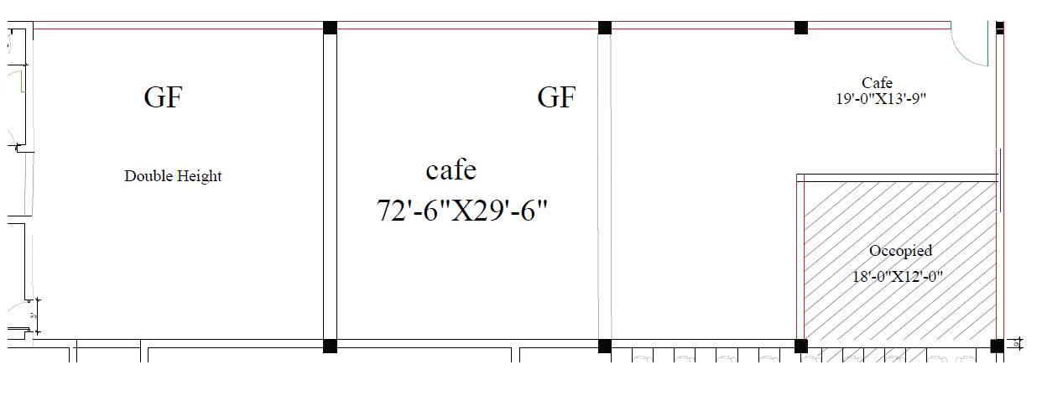

Open Lawn Open Air

135′x 70′

